CSIT314 Software Development Methodologies - Group Project

Sprint 3 - US21: View current IDPs
Interior Design Platform - Interior Designer
All diagrams were drawn in draw.io. Open "US21 View current IDPs.drawio" in this folder to edit them - each diagram is its own page in that file. The exported images are in the "diagrams" folder.

Assumptions
- The system is the Interior Design Platform from the project specification. Sprint 3 covers the Interior Designer's current IDP stories (add, view, update, delete and search, US20 - US24) and the Customer's log in, IDP search, IDP view and log out stories (US30 - US32, US36).
- We follow B-C-E: the actor only talks to the boundary (page), the boundary only talks to the controller, and the controller works with the entity classes. There is one controller per use case.
- The boundary checks all the input (required fields, lengths, formats, e.g. not suspending your own profile) and trims spaces, then passes an entity object on. The controller just calls the entity and returns the result. The entity checks for duplicates and the database state (e.g. name already used, only Active rows are changed), then saves. In US21 there is no typed input: the page takes designerId from the session (and idpId from the URL), the controller just calls the entity, and the entity only returns the owner's Active Current IDPs whose category is Active.
- An IDP is an interior design project. A current IDP is one the designer is still working on (US20 - US24); a past IDP is a completed one (US25 onwards). Both are rows in the idp table with projectType Current or Past.
- Logged in as an interior designer (UC13) is the precondition. designerLoginRequired in app.py only sends someone with no session to /designer/login; the use case doesn't check the designer again (no InteriorDesignerLoginController).
- The list shows the designer's own Active Current IDPs in Active categories, newest first (by idpId). Past and Suspended IDPs, other designers' IDPs and IDPs in a Suspended category (US44) are not shown.
- Selecting an IDP shows what customers see: title, category name, description and location (an empty location is left out). categoryName is joined from the category table for display; it isn't a column of idp.
- No current IDPs is a normal page with "You have no current IDPs to display". An IDP that is missing, someone else's, Past, Suspended or in a Suspended category gives "Current IDP not found" (HTTP 404) without showing any details.
- Viewing is read-only: it changes no IDP and isn't counted as a customer view (US32, US37). Photos are not part of this story.

1. User story
Story ID | US21
User story | As an interior designer, I want to view my current IDPs so that I can check how they look to customers.
Actor | Interior Designer
Priority | Medium
Story points (estimate) | 2
Acceptance criteria | 1. Given I am logged in as an interior designer, when I click "View current IDPs" on the dashboard, then I see only my own Active Current IDPs (in Active categories), newest first.  2. Given I click "View" on an IDP, then I see its title, category, description and location as customers would see them, with "Back to list".  3. Given I have no current IDPs, then I see "You have no current IDPs to display".  4. Given the IDP is missing, not mine, Past, Suspended or in a Suspended category, then I see "Current IDP not found" (HTTP 404) and none of its details.  5. Viewing does not change any IDP or the customer view statistics.
Tasks | #140 Develop current IDP listing and details display  #149 Draw Use Case Diagram and Description  #159 Draw BCE and Sequence Diagram  #169 Design Wireframe  #179 Write and Execute Test Cases

2. Use case diagram
The user story becomes one use case, UC21 View current IDPs. The Interior Designer is the only actor. Listing, selecting an IDP and the empty and not-found results are flows of this use case.
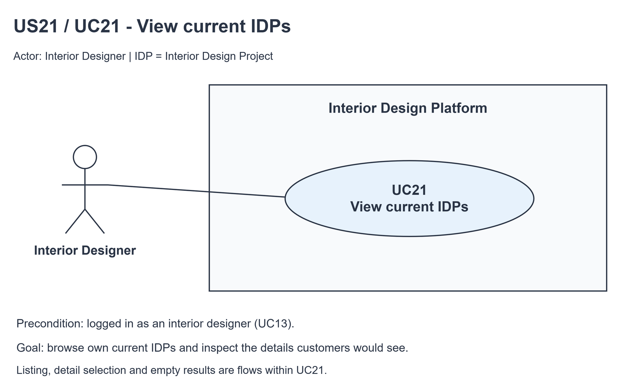
Figure 1: Use case diagram for US21 View current IDPs

3. Use case description
Use case | UC21 View current IDPs
Actor | Interior Designer
Brief description | The Interior Designer lists their current IDPs and opens one to check how it looks to customers.
User story | US21: As an interior designer, I want to view my current IDPs so that I can check how they look to customers.
Preconditions | The Interior Designer is logged in (UC13). designerLoginRequired in app.py only sends someone with no session to /designer/login.
Trigger | The Interior Designer clicks "View current IDPs" on the dashboard.
Basic flow | 1. The Interior Designer clicks "View current IDPs".  2. The system gets the designer's Active Current IDPs whose category is Active, newest first.  3. The system shows the list with a "View" link for each IDP.  4. The Interior Designer clicks "View" on an IDP.  5. The system gets that IDP if it is still the designer's Active Current IDP in an Active category.  6. The system shows its title, category, description and location as customers see them, with "Back to list".
Alternative flows | 2a. The designer has no current IDPs: the system shows "You have no current IDPs to display" and "Back to dashboard". The use case ends.  5a. The IDP is missing, someone else's, Past, Suspended or in a Suspended category: the system shows "Current IDP not found" (HTTP 404) with "Back to list". No details are shown.
Postconditions | Nothing is changed - no IDP and no customer view statistics.

4. Wireframes
The wireframes were drawn in draw.io. They are low-fidelity: they show the layout and the flow, not the final colours.

4a - Current IDPs list
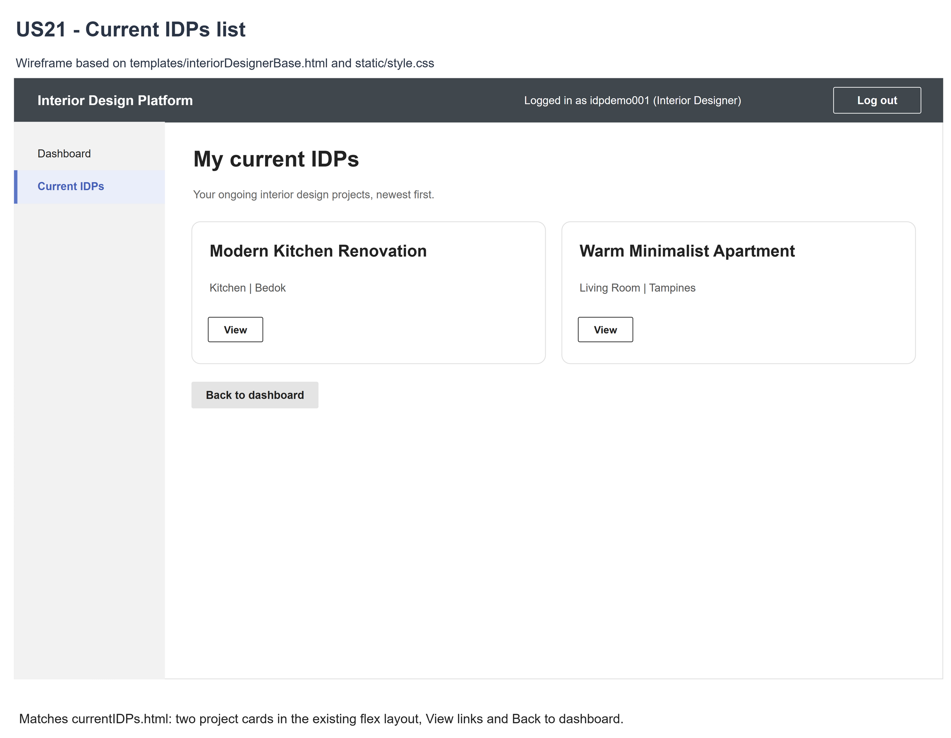
Figure 2: Wireframe 4a - Current IDPs list (US21)

4b - Current IDP details
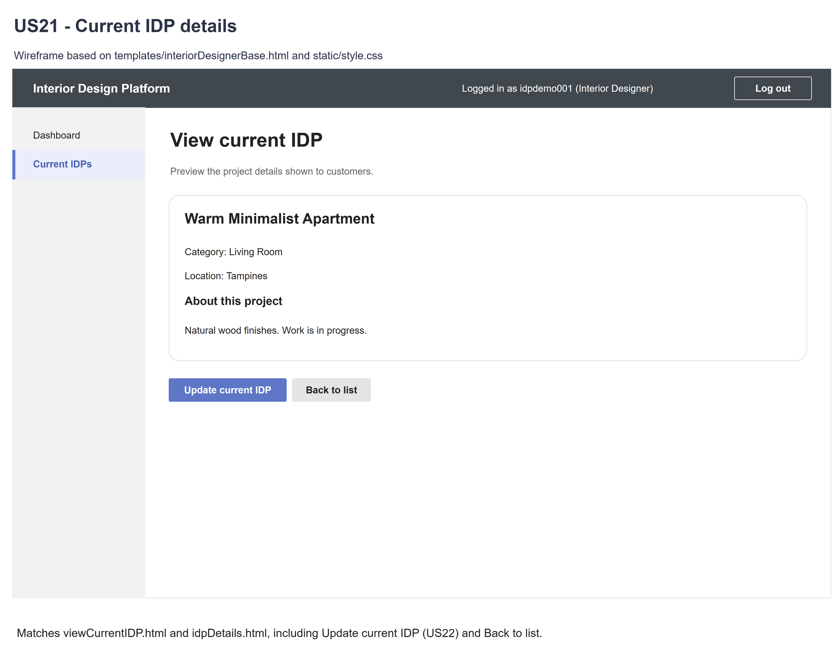
Figure 3: Wireframe 4b - Current IDP details (US21)

4c - No current IDPs
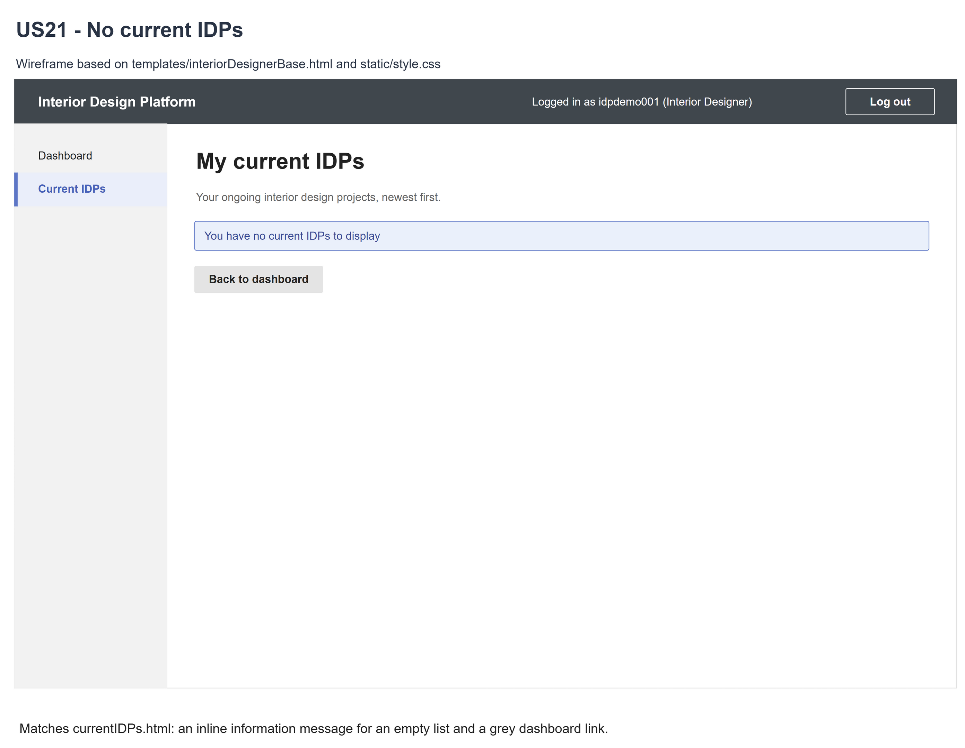
Figure 4: Wireframe 4c - No current IDPs (US21)

4d - Current IDP not found
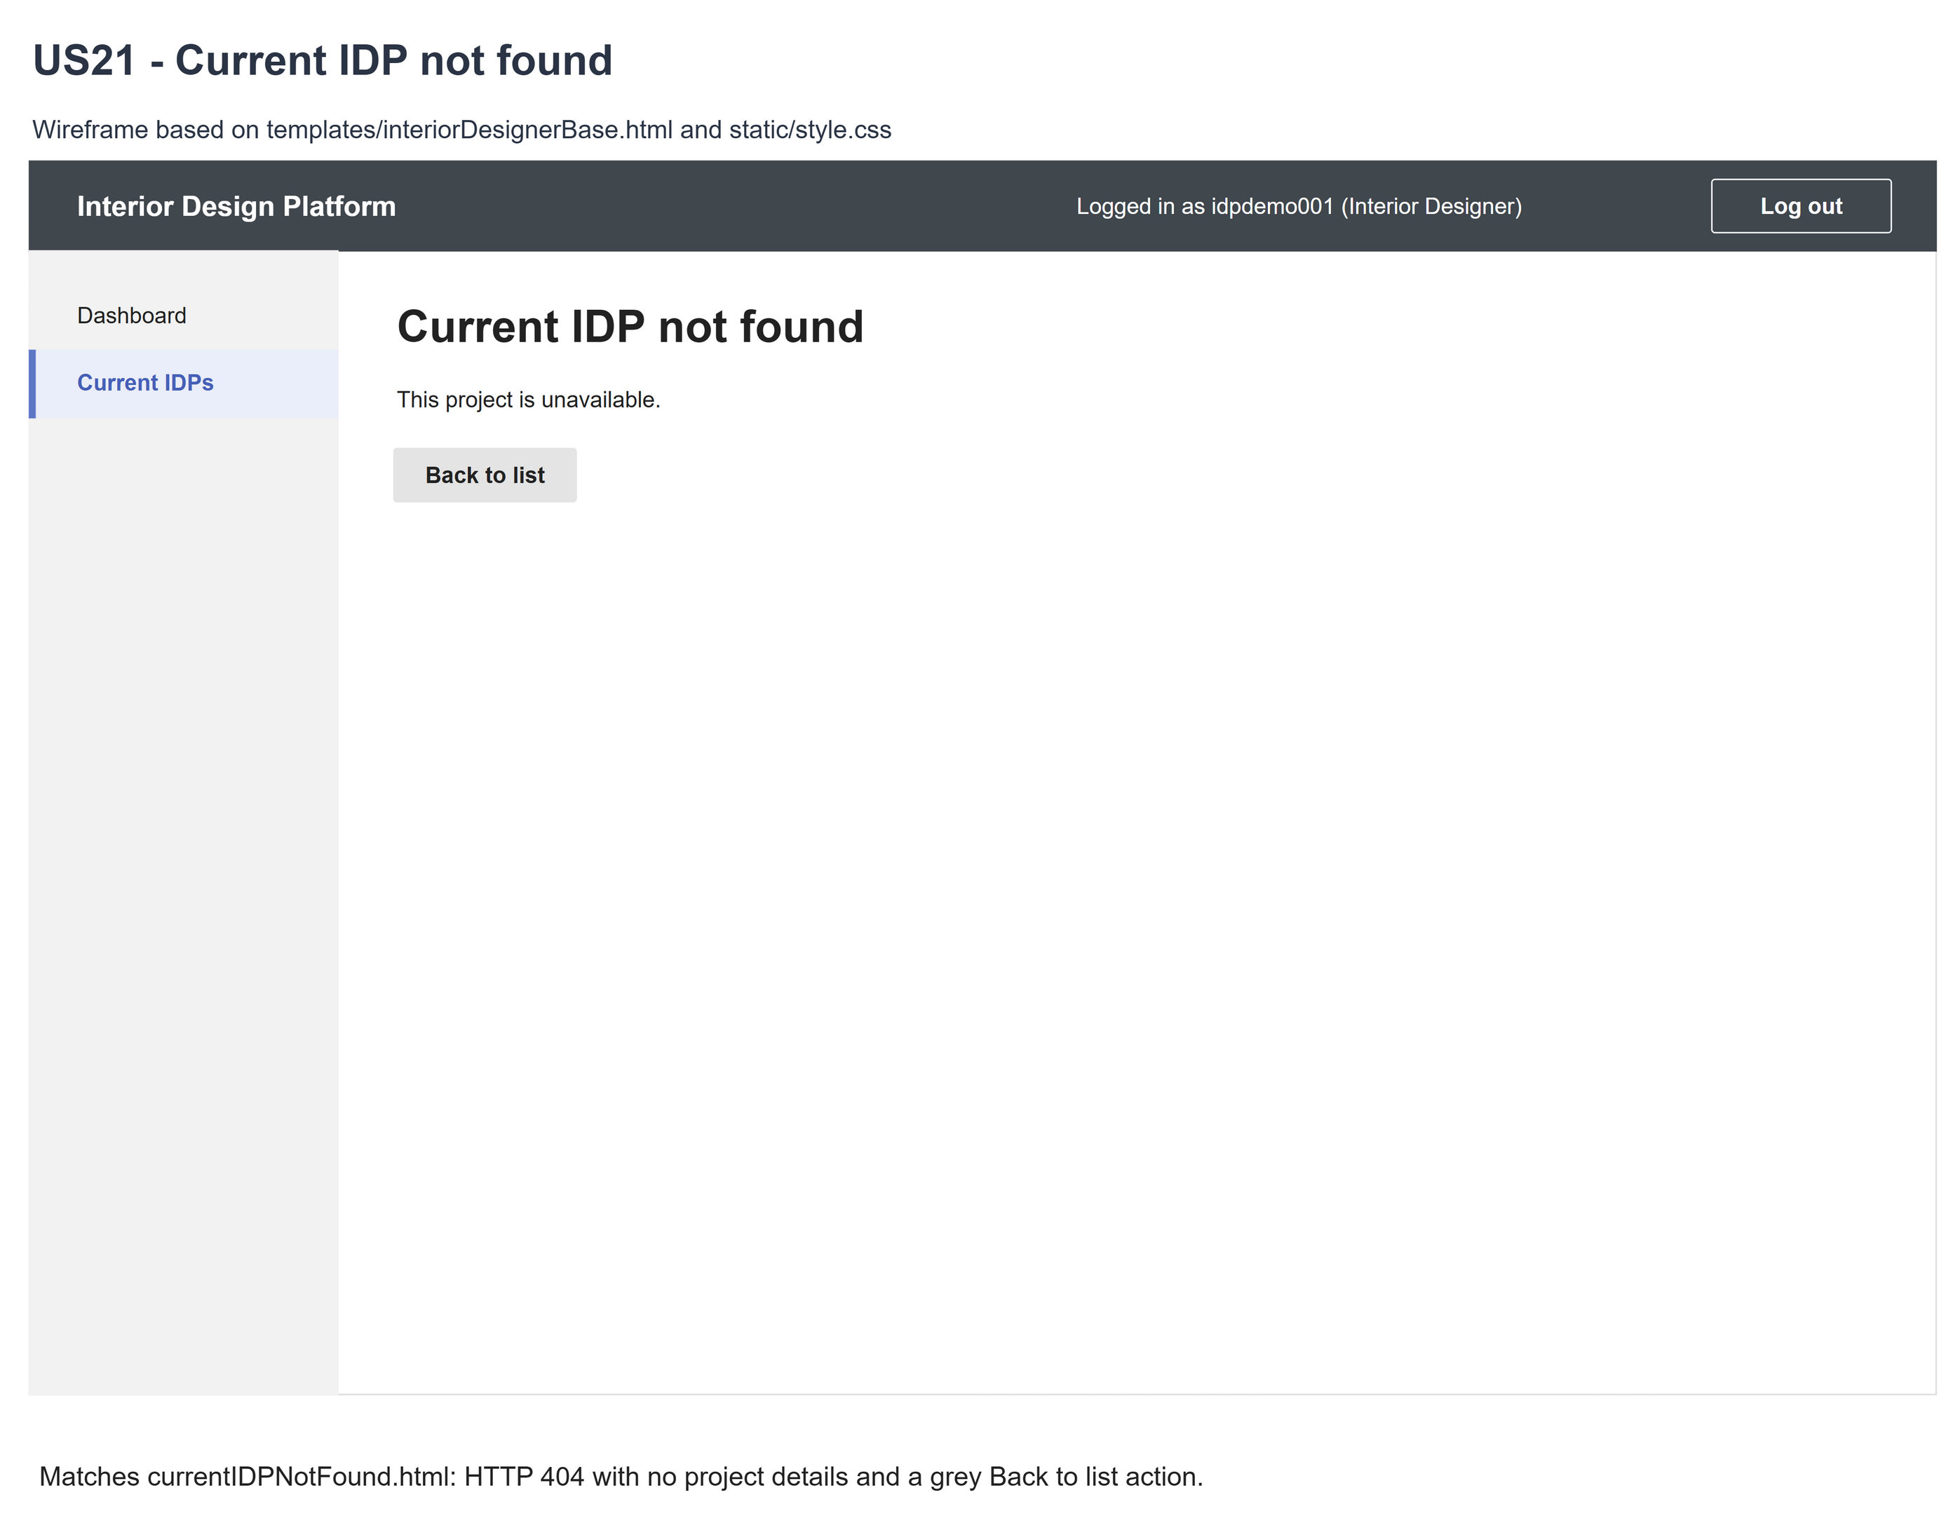
Figure 5: Wireframe 4d - Current IDP not found (US21)

5. B-C-E class diagram
The solid line means the boundary calls the controller. The dashed line means the controller uses the entity. Only the operations needed for this use case are shown.
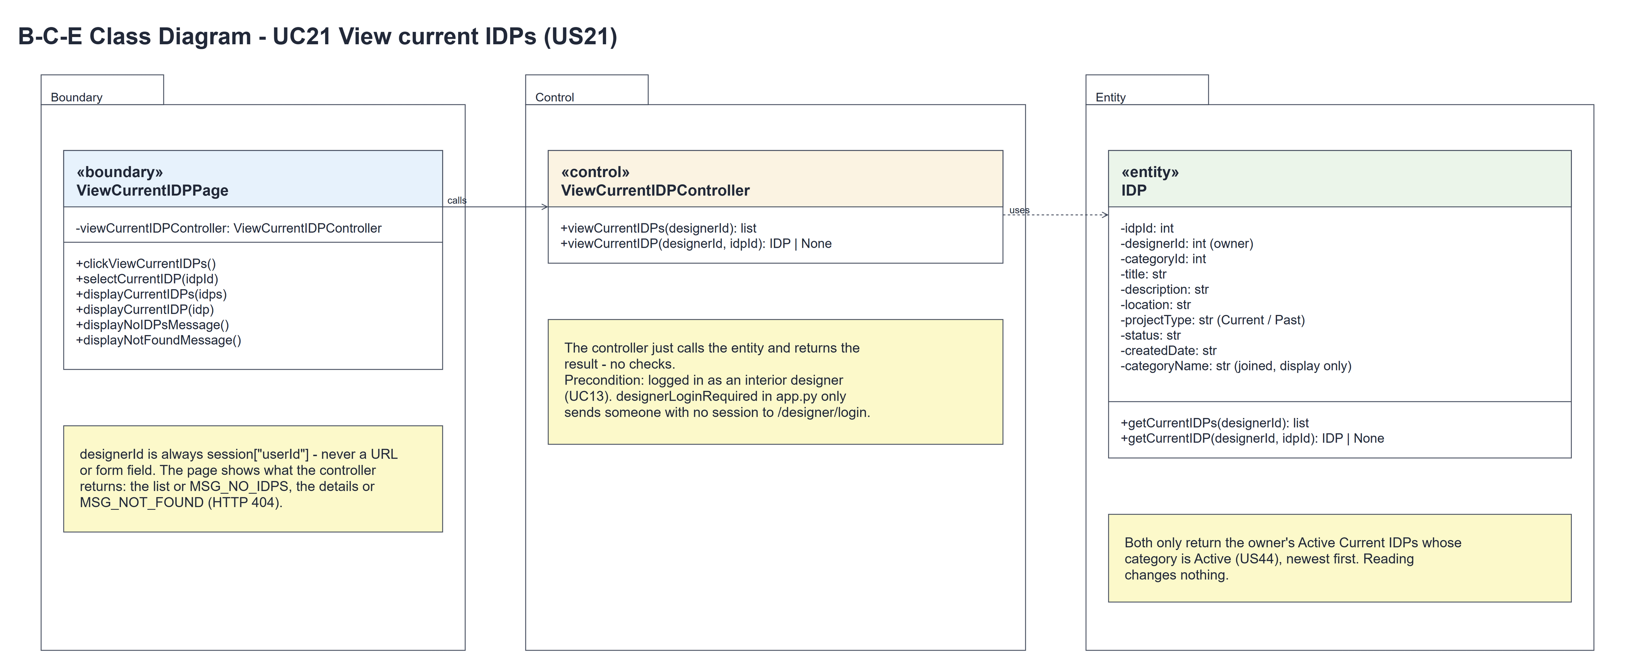
Figure 6: B-C-E class diagram for US21 View current IDPs
Layer | Class | What it does
Boundary | ViewCurrentIDPPage | The list and detail pages. clickViewCurrentIDPs() and selectCurrentIDP(idpId) take designerId from the session, call the controller and show the result: displayCurrentIDPs(idps) or displayNoIDPsMessage(), and displayCurrentIDP(idp) or displayNotFoundMessage() (HTTP 404).
Control | ViewCurrentIDPController | Controller for UC21. viewCurrentIDPs(designerId) and viewCurrentIDP(designerId, idpId) just call the entity and return the result - no checks.
Entity | IDP | The only entity. getCurrentIDPs(designerId) and getCurrentIDP(designerId, idpId) only return the owner's Active Current IDPs whose category is Active, with the joined categoryName for display.

6. Sequence diagram
The sequence diagram follows UC21. Clicking "View current IDPs" calls viewCurrentIDPs(designerId), which makes one call to IDP.getCurrentIDPs() (steps 1-2); the first alt shows the list (step 3) or "You have no current IDPs to display" (2a). Selecting an IDP calls viewCurrentIDP(designerId, idpId), which makes one call to IDP.getCurrentIDP() (steps 4-5); the second alt shows the details (step 6) or the not-found page (5a). Being logged in is the precondition, so the designer is not checked again.
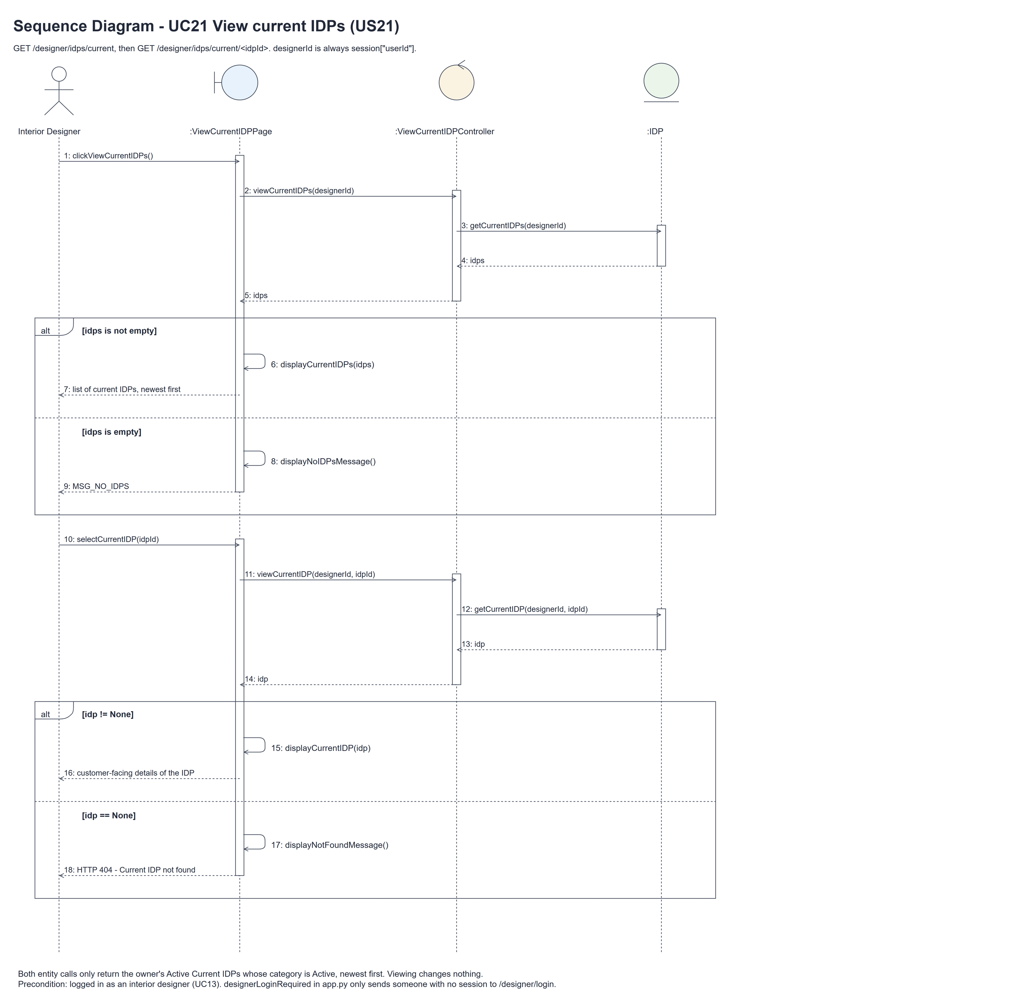
Figure 7: Sequence diagram for UC21 View current IDPs

7. Test cases
Test data used below (the same as tests/test_us21_viewCurrentIDPs.py): designer accounts designer21 (A) and designer22 (B) / Design@123, made with UC8. IDP categories Living Room (Active) and Hidden Category (Suspended). A owns the Active Current IDPs "Warm Minimalist Apartment" and "Modern Kitchen Renovation" (Living Room, Tampines) plus a Past IDP, a Suspended IDP and an IDP in Hidden Category. B owns "Other Designer Private Project".

7a. System test cases (black box)
Equivalence partitioning and boundary value analysis were used to pick the test data. Fill in "Actual result" and "Pass/Fail" after running each test.
Test ID | Scenario | Prerequisites | Test steps | Test data | Expected result | Actual result | Pass / Fail
TC21.1 | Own current list | Logged in as A; the test data above. | 1. Click "View current IDPs" | A: 2 Active Current IDPs; B: 1 | Only A's two IDPs, newest first.
TC21.2 | Customer-facing details | Logged in as A. | 1. Open the list / 2. Click "View" | Warm Minimalist Apartment | Title, category, description and location; "Back to list".
TC21.3 | No current IDPs | Logged in as A; A has no current IDPs. | 1. Click "View current IDPs" | No IDPs | "You have no current IDPs to display" (HTTP 200).
TC21.4 | One IDP | A has exactly one current IDP. | 1. Open the list / 2. Click "View" | One IDP | One item and its correct details.
TC21.5 | Another designer's IDP | Logged in as A. | 1. Open B's IDP URL directly | B's idpId | "Current IDP not found" (HTTP 404); none of B's details.
TC21.6 | Past or Suspended IDP | Logged in as A. | 1. Open the list / 2. Open the excluded IDPs' URLs | A's Past IDP; A's Suspended IDP | Not in the list; both URLs give HTTP 404.
TC21.7 | Suspended category | Logged in as A. | 1. Open the list / 2. Open that IDP's URL | IDP in Hidden Category | Not in the list; the URL gives HTTP 404.
TC21.8 | Missing or invalid id | Logged in as A. | 1. Open each URL | 0, -1, 999999 | HTTP 404; no details.
TC21.9 | Not logged in | Not logged in. | 1. Open the list and a detail URL directly | - | Sent to the designer login page for both.
TC21.10 | Profile suspended after logging in | Logged in as A; then A's profile is suspended (UC6). | 1. Open the list again / 2. Log out and log in again | - | The list still opens for this session - being logged in is the precondition (UC13), so it isn't checked again. The next login is refused. | The list still opened (HTTP 200) after the profile was suspended. After logging out, the next login showed "Invalid login details or access unavailable". | Pass
TC21.11 | IDP hidden after listing | A's list is open. | 1. Suspend the IDP or its category / 2. Click the old "View" link | - | HTTP 404 "Current IDP not found".
TC21.12 | Empty location, read-only | A's IDP has no location. | 1. Open the details twice / 2. Go back to the list | Empty location | No empty "Location:" line; the IDPs and the view statistics are unchanged.

7b. Unit test cases (for TDD)
These are written before the code (test-driven development) and run with pytest (python -m pytest). They cover normal inputs, abnormal inputs and boundary values. Each one matches a test function in tests/test_us21_viewCurrentIDPs.py (UT21.1 is test_ut21_1_...). "Pass" is from the pytest run on 10 November 2026.
Test ID | Class and method | Input / setup | Expected output | Type | Pass / Fail
UT21.1 | IDP.getCurrentIDPs() | A owns 2 Active Current IDPs; B owns 1 | Only A's IDPs | Normal | Pass
UT21.2 | IDP.getCurrentIDPs() | A owns an Active Past IDP | The Past IDP is left out | Abnormal | Pass
UT21.3 | IDP.getCurrentIDPs() | A owns a Suspended Current IDP | The Suspended IDP is left out | Abnormal | Pass
UT21.4 | IDP.getCurrentIDPs() | Active IDP in a Suspended category | The IDP is left out | Abnormal | Pass
UT21.5 | IDP.getCurrentIDPs() | Zero / one / many IDPs | [] / one / all of them | Boundary | Pass
UT21.6 | IDP.getCurrentIDPs() | idpIds 10, 12, 11 | Order 12, 11, 10 | Normal | Pass
UT21.7 | IDP.getCurrentIDP() | A + A's own idpId | The IDP with the right fields and categoryName | Normal | Pass
UT21.8 | IDP.getCurrentIDP() | A + B's idpId | None | Abnormal | Pass
UT21.9 | IDP.getCurrentIDP() | A's Past / Suspended IDP | None for each | Abnormal | Pass
UT21.10 | IDP.getCurrentIDP() | A's IDP in a Suspended category | None | Abnormal | Pass
UT21.11 | IDP.getCurrentIDP() | idpId 0 / -1 / 999999 | None for each | Boundary | Pass
UT21.12 | ViewCurrentIDPController | Look at the class | Only viewCurrentIDPs() and viewCurrentIDP() - no access-check method and no login controller | Normal | Pass
UT21.13 | ViewCurrentIDPController.viewCurrentIDPs() | A's account, profile or permission changed after logging in | Still returns A's IDPs - the controller doesn't check the designer again (precondition UC13) | Abnormal | Pass
UT21.14 | ViewCurrentIDPController.viewCurrentIDPs() | designerId A; the entity returns [] | Calls IDP.getCurrentIDPs(A) once and returns its result | Normal | Pass
UT21.15 | ViewCurrentIDPController.viewCurrentIDP() | designerId A and an idpId | Calls IDP.getCurrentIDP(A, idpId) once and returns its result | Normal | Pass
UT21.16 | Both controller methods | InteriorDesignerLoginController would return None | No exception - each method makes one entity call and returns the result | Abnormal | Pass
UT21.17 | designerLoginRequired (app.py) | GET the list and a detail URL, not logged in | Redirects to /designer/login | Abnormal | Pass
UT21.18 | List and detail pages | admin01 logged in on /login, cust001 on /customer/login | The role isn't checked again (precondition UC13): the list gives HTTP 200 with "You have no current IDPs to display"; another designer's IDP gives HTTP 404. Never forbidden | Abnormal | Pass
UT21.19 | ViewCurrentIDPPage.clickViewCurrentIDPs() | The controller returns [] | "You have no current IDPs to display" (HTTP 200) | Boundary | Pass
UT21.20 | ViewCurrentIDPPage.selectCurrentIDP() | A's own IDP | Only the customer-facing fields; no account details or form fields | Normal | Pass
UT21.21 | ViewCurrentIDPPage.selectCurrentIDP() | Other / Past / Suspended / hidden / missing idpId | "Current IDP not found" (HTTP 404); no details | Abnormal | Pass
UT21.22 | List and detail pages | designerId / userId of B added to the URL | Only the session owner A is used | Abnormal | Pass
UT21.23 | Detail page after listing | Then: suspend the IDP, suspend its category or make it Past; or suspend A's account / profile / permission | IDP changes: HTTP 404. Account changes: not checked again, the list and details still give HTTP 200 | Abnormal | Pass
UT21.24 | List and detail pages | Open both twice | The database is unchanged | Normal | Pass
UT21.25 | ViewCurrentIDPPage.selectCurrentIDP() | A's IDP with an empty location | HTTP 200; no "Location:" line and no "None" on the page | Boundary | Pass
UT21.26 | List and detail pages | <script> text in the title, description, location and category name | Shown escaped, not run | Abnormal | Pass
UT21.27 | Dashboard and list page | A opens the dashboard, then the list | The dashboard links to /designer/idps/current; the list shows Modern Kitchen Renovation before Warm Minimalist Apartment (newest first), a View link for each, and not B's IDP | Normal | Pass
UT21.28 | List and detail pages | POST, PUT, PATCH and DELETE | HTTP 405; the database is unchanged | Abnormal | Pass
UT21.30 | initDatabase() (database/db.py) | Run it twice on a database that already has IDPs | The existing data is unchanged | Normal | Pass
UT21.31 | seedCurrentIDPData() (database/seedCurrentIDPData.py) | Run it twice, then log in as idpdemo001 and open the list | Adds 4 demo IDPs the first time and nothing the second time; the list shows Warm Minimalist Apartment and Modern Kitchen Renovation | Normal | Pass

